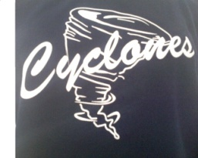
2012-2013 Fastpitch Softball Season
Adopt-A-Player Sponsorship Program

Dear Friends, Family and Fellow Softball Supporters:
Orange County Cyclones Organization has been providing young women with a safe, quality environment for learn and play. As the proud parents, friends, and supporters of our Orange County Cyclones Players we would like to offer you the opportunity to show your girls your support by adopting a player. Our Adopt-A-Player program is just one way for us to fundraise to help our girls with their travel softball costs throughout the season. ALL funds raised through our Adopt-A-Player program go toward funding for tournaments, meals and team athletic apparel.
Our team has been working very hard in order to prepare for the upcoming season, and we are eagerly anticipating a successful year. We hope you are able to support us as much as possible. Thank you in advance for your consideration.
Thank you and warmest regards….
Orange County Cyclones
Please complete bottom portion and return to player:
------------------------------------------------------------------------------------------------------------------------------------------
Player Adopted_________________________________________________________________
Sponsor’s Name________________________________________________________________
Address:_______________________________________________________________________
City_____________________________ State_________________ Zip______________________
For your donation of $25 your name will appear on our website under our Adopt-A-Player Program with the player you are sponsoring. You will also receive a Orange County T-Shirt for your thanks and appreciation.
T –Shirt Sizes (please circle)
Adults: S M L XL XXL
***Additional T-Shirt, along with adoption add ($12)
PLEASE MAKE CHECKS PAYABLE TO: Orange County Cyclones

